Practical No 5

Aim: Write a program to find maximum and minimum of given set of integer values.
Software Requirements: Python IDE, Pycharm, Visual Studio Code, Jupyter Notebook
Theory:
The task of finding the maximum and minimum values in a list of integers is a fundamental operation in programming. This is useful in various applications such as statistical analysis, data comparison, and optimization problems.
This program takes a set of integer values as input from the user and determines the maximum and minimum values using Python’s built-in functions max() and min().
Steps to Solve the Problem:
- Input Handling: Read a list of space-separated integers from the user.
- Initialize Variables: Assign the first element as both max_value and min_value.
- Iterate Through the List:
  - Compare each element with max_value, updating it if the element is larger.
  - Compare each element with min_value, updating it if the element is smaller.
- Return the Results: Print the maximum and minimum values.

Program:
def find_max_min(numbers):
max_value = min_value = numbers[0] # Initialize with the first element

for num in numbers:
if num > max_value:
max_value = num
if num < min_value:
min_value = num

return max_value, min_value

# Taking user input
numbers = list(map(int, input("Enter integers separated by spaces: ").split()))

# Finding max and min
maximum, minimum = find_max_min(numbers)

# Displaying results
print("Maximum value:", maximum)
print("Minimum value:", minimum)
Example:
Input
Enter integers separated by spaces: 10 5 25 8 15 2 30

Processing:
- max_value = 10, min_value = 10 (Initial values)
- Iterate through the list:
  - 5 → Update min_value = 5
  - 25 → Update max_value = 25
  - 8 → No change
  - 15 → No change
  - 2 → Update min_value = 2
  - 30 → Update max_value = 30
Output:
Maximum value: 30
Minimum value: 2

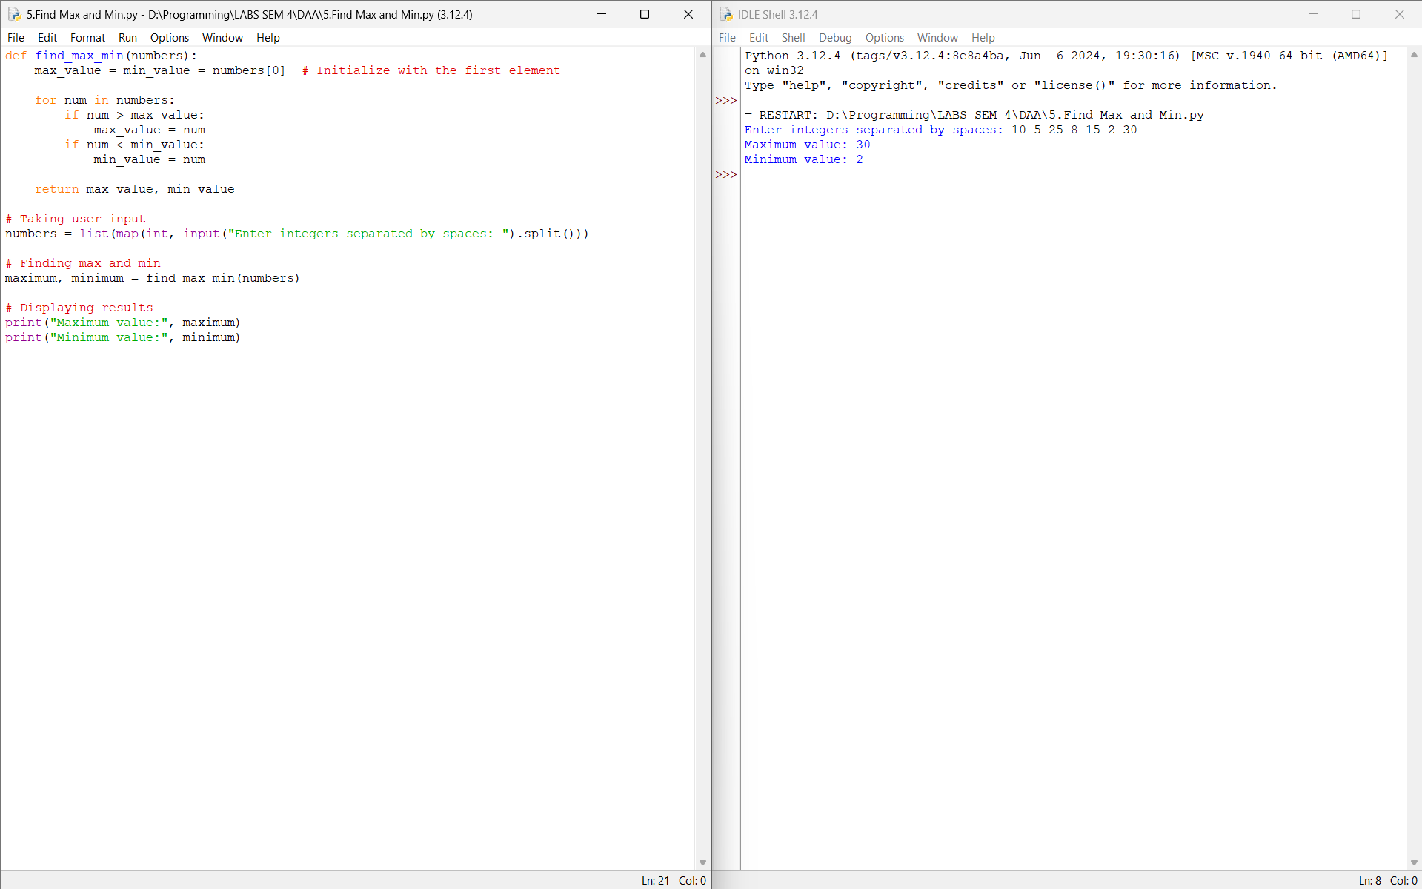
Conclusion:
Hence, I have executed the python program to find maximum and minimum of given set of integer values.

